## 

## 

## 

## AutoSource

Adam Ilarde, Angel Portillo, Doug Cerrato

CMPS 3420-01 Spring 2023

## 

## 

## 

## 

**AutoSource 1**

**1.1 - Fact-Finding Techniques and Information Gathering 3**

1.1.1 - Introduction to the Enterprise/Organization 3

1.1.2 - Preliminary Research 3

1.1.3 - The Miniverse of Interest 3

1.1.4 - User Groups, Data Views, and Operations 4

1.1.5 - Summary of Entities and Relationships 4

**1.2 - Conceptual Database Design 5**

1.2.1 - Entity Descriptions 5

1.2.2 - Relationship Descriptions 10

1.2.3 - Enhanced ER Descriptions 11

1.2.4 - ER Diagram 12

**2.1 - The ER and Relational models: 13**

**2.2 - Conceptual to Logical Conversion Process 15**

**2.2.1 - Converting Entity Types to Relations 15**

2.2.2 - Converting Relationship Types to Relations 16

2.2.3 - Converting Extended Types to Relations 16

**2.3 - Results of ER to Relational Conversion 18**

2.3.1 Relation Schema 18

**3.1 - Sample Queries 20**

3.1.1 Design Of Queries 20

3.1.2 Relational Calculus Expressions 21

3.1.3 Relational Algebra Expressions 23

**3.2 - Database Implementation 26**

3.2.1 Background Information 26

3.2.2 Schema 28

4.1.1 - Introduction 31

4.1.2 - Syntax of Programming Logic 33

4.2 - Query Implementation 34

4.3 - Programming Implementation 35

4.3.1 - Views 35

4.3.2 - Stored procedures 35

4.3.3 - Triggers 36

5.1 - GUI Functionalities and User Groups 37

5.1.1 - User Capabilities 37

5.1.2 - Screenshots and Walkthrough 37

5.2 - GUI Programming 37

5.2.1 - Server-side Programming 37

5.2.2 - Middle-tier Programming 37

5.2.3 - Client-side Programming 38

## **1.1 - Fact-Finding Techniques and Information Gathering**

### 1.1.1 - Introduction to the Enterprise/Organization

* Many people experience needing to replace car parts and proceed to go to many websites to research for the right part they need. We plan to create a website where we have a database that bundles the data from different websites and puts it all in one place in a user-friendly environment. We took inspiration from the custom pc builder from NewEgg where we have a section where the user can input their make and model of their vehicle and will list out the parts that are in it, and where they select a part and it lists where they can get that part and how much it is.

### 1.1.2 - Preliminary Research

* We plan to gather information through various websites and sources, such as the maker of the car’s website like Toyota, Honda, etc. Also we are taking information from autopart store websites such as AutoZone and PartGeeks as well as car manuals that provide the information.
* Angel Portillo has always self-serviced his vehicles, and in doing so, has had to purchase parts from numerous types of vendors. From in person local part stores, aftermarket performance shops, and local dealerships. Having personal experience as a buyer through all available ways to purchase parts Angel has a perspective that will help build an application that can be beneficial. To gather more information to provide a better understanding of what we can bring to this business we will be looking to Angel’s parts dealer who restores classics and his father who has managed several dealer service and parts depts both having been in the Automotive industry for over 30yrs.

### 1.1.3 - The Miniverse of Interest

* What our goal is with our application is to be a one stop source for any information a customer would need. Currently, it would take multiple searches. Information for OEM replacement parts or performance parts cannot be found in one place, and that is what we would like to achieve. To be able to do this for every car would not be realistic but we would like to provide this service for a few main companies, that being Toyota, Ford, and Chevy as these are the top 3 leading car brands in the United States. Additionally, the national average age of a car on the road is 12 years old, so we will keep our database for cars that are 2000 and newer.

### 1.1.4 - User Groups, Data Views, and Operations

* Members
* People who have an account for this site will have all their information that they input saved, such as basic personal information, information of their vehicle, and parts that they have in mind saved, so they won’t have to look for it again.
* Will have a login feature to store their personal information such as personal vehicles. Once logged in they will have a custom information hub that will provide useful info based on the users’ vehicles. Additionally, they will have the ability to search our database to locate parts that are compatible with their vehicles.
* Admins
* Will have the ability to manage member profiles, such as reset password, and have the capabilities to remove and add data to the application.

### 1.1.5 - Summary of Entities and Relationships

Our entities listed are: Admin, Member, Vehicle, Parts, Part Category

* The member can own many vehicles, and the vehicles can be owned by more than one member.
* The vehicle has many parts, and the parts fit many vehicles.
* The parts are in a part category, but the part category has many parts.
* All parts are managed by admin, and the many admin manage the parts.

## **1.2 - Conceptual Database Design**

### 1.2.1 - Entity Descriptions

* **Parts Category**
* Strong because it doesn’t depend on any other entity.
* Attribute: Part Category name
* A general label to group similar parts ex)interior, exterior, electrical, etc.
* This is a generic attribute.
* Multivalued because there are different parts that are contained in each category
* This is simple because it cannot be subdivided.
* This is stored because this is being tracked.

* **Parts**
* This entity is strong.
* Attribute: Part name:
* The name given to the specific part.
* This attribute is not unique because the name of parts can be associated with many parts.
* This is a multi-valued attribute because many parts can have similar names.
* This is a stored attribute because we are storing it.
* Attribute: Part Serial Number:
* The serial number for that specific part.
* This attribute is unique because each part has its own serial number which could identify that specific part.
* This is a single-valued attribute because it can’t store more than one value.
* This is a simple attribute because it can’t be subdivided.
* This is a stored attribute because the serial number for the part is being tracked.
* Attribute: Price:
* The price for the car part.
* This attribute is not unique because the parts could have the same prices.
* This is a single-valued attribute because it cannot store more than one value for the price.
* This is a simple attribute because the price cannot be subdivided.
* This is a stored attribute the price of the part is being tracked by the admin and would change based on external websites prices.
* **Vehicle**
* This entity is weak because it depends on the member. The vehicle only exists if the member has imputed their information on the website.
* Attribute: VIN:
* This is a number that is specific to one vehicle.
* This is a unique attribute because no car will have the same VIN number.
* This is a single-valued attribute because a specific vehicle cannot have more than one.
* This is simple because it cannot be subdivided.
* This is a stored attribute because the user can input the VIN to make sure a part fits their specific vehicle.
* Attribute: Make:
* This is the vehicle manufacturer.
* This is not unique because many users could have a vehicle from the same manufacturer.
* This is a single valued attribute because the vehicle cannot be from more than one manufacturer.
* This is simple because the make cannot be subdivided.
* This is a stored attribute because the user inputs the make of their vehicle which would be tracked by the website.

* Attribute: Model:
* The model of the vehicle.
* This is not unique because many users can have the same model of vehicle.
* This is a single-valued attribute because the vehicle cannot be more than one model.
* This is simple because it cannot be subdivided.
* This is a stored attribute because the model of their vehicle is being tracked and be used so the site can find specific parts for that model.
* Attribute: Year:
* The year that the vehicle was made.
* This attribute is not unique because many vehicles are made in the same year.
* This attribute is single-valued because each vehicle is specific to each year.
* This is a simple attribute because it cannot be subdivided.
* This is stored because the site keeps track of the year the car was made so that it could find parts that could fit their vehicle.

* **Admin**
* This entity is strong because the administrators do not depend on any other entity.
* Attribute: Employee ID:
  + ID used to recognize employees and a part of Sign In.
  + This is unique to each User/Admin.
  + Single valued since each employee has only **ONE** employee ID
  + The attribute is simple because it cannot be subdivided.
  + Finally, the attribute is stored to confirm Employee ID with the corresponding password.
* Attribute: Password
  + Employees password used to sign onto the site and work on it.
  + The password is not unique, since there is the possibility of multiple admin having the same password unintentionally.
  + Single value since each Employee has their own single password.
  + The attribute is simple since there are no subdivided attributes.
  + Finally, the password is stored in a Hash Encrypted form to confirm login.
* Attribute: First Name
* First name of admin.
* Not unique because many admins could have the same first name
* Single valued since a person can only have one first name
* Simple because it cannot be subdivided.
* Stored because the database stores their name.
* Attribute: Last Name
* Last name of admin.
* Not unique because many admins could have the same last name
* Single valued since a person can only have one last name
* Simple because it cannot be subdivided.
* Stored because the database stores their last name.
* **Member**
* Strong because the member can stand on its own and doesn't need any other entity.
* Attribute: Password
* This is the password that the member uses to login to their account.
* This attribute is not unique because many people could have the same password.
* This is a single valued attribute.
* This attribute is simple because it doesn’t connect to different attributes.
* This is stored because the password is saved and is used to let the user access their information that they have saved.

* Attribute: Email
* The email of the member.
* This is unique to each member because they have their own email.
* This is a single valued attribute.
* This is also simple because there are no subdivided attributes.
* This attribute is stored because the site would keep track of their email which would identify what user is accessing the site and can pull out the information that is saved for that user..
* Attribute: First Name
* First name of member.
* Not unique because many member could have the same first name
* Single valued since a person can only have one first name
* Simple because it cannot be subdivided.
* Stored because the database stores their name.
* Attribute Last Name
* Last name of member.
* Not unique because many member could have the same last name
* Single valued since a person can only have one last name
* Simple because it cannot be subdivided.
* Stored because the database stores their last name.

### 1.2.2 - Relationship Descriptions

* **Relationship between Member and Vehicle**
  + The purpose of this relationship is that each member owns vehicles that they enter onto the site.
  + The entities involved are the Members and the Vehicles
  + The cardinality for this relationship is one to many (M:N) since each member can own multiple vehicles, and the vehicles can be associated with many members.
  + The participation is unspecified
* **Relationship between Vehicle and Parts**
  + The purpose of this relationship is that each vehicle has parts.
  + The entities involved are the Vehicles and the Parts
  + The cardinality for this relationship is many to many (M:M) as there are many vehicles that can be stored on the site, as well as the many parts that can fit the parts.
  + Participation is mandatory because all vehicles must have some parts.
* **Relationship between Parts and Part Category** 
  + The purpose of this relationship is the parts sorted in the part category.
  + The entities involved are the Parts and the Parts Category.
  + The cardinality of this relationship is one to many (1:M) as there is one part category the parts are sorted in, however the part category has multiple parts.
  + The participation is mandatory, as the parts have to be in the part category.
* **Relationships between Parts and Admin**
  + The purpose of this relationship is that the Admin manage and input the Parts into the website.
  + The entities involved are the Parts and the Admin
  + The cardinality of this relationship is many to many (M:N) as there are many admin inputting many parts.
  + The participation is mandatory because all parts must be managed by someone in Admin.

### 1.2.3 - Enhanced ER Descriptions

### 1.2.4 - ER Diagram

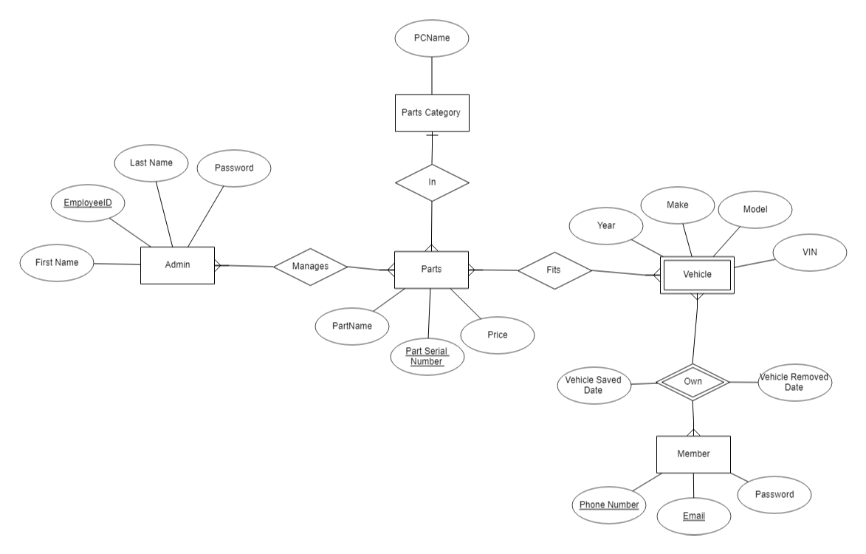

## **2.1 - The ER and Relational models:**

ER models and Relational models are types of data models that are used in Database Management Systems. The ER model stands for the Entity- Relationship model and was developed by Peter Chen in 1976. The model grew in popularity as the need to properly understand databases and real-world businesses became crucial. Although Peter Chen receives the credit for the model we currently use today, he was not the first to try and model databases. Charles Bachman developed the Bachman Diagram in the late 60s and he actually used the term entities. He is said to be a major influence in what Peter Chen created. ER Diagrams at their roots are used to design because they can easily be converted to relational tables and debug since it requires very little database knowledge it can be used to explain as a designer to others.

The Relational model is used to model the logical view of a system from the perspective of the data in relations or tables and was developed by E.F. Codd in the 1970’s. One can create a relational model by using the ER model created for that database and converting it to a relational model by using the entities and attributes from the ER model and using a nine step algorithm to convert ER constructs to their relational versions. These steps are strong entities, weak entities, binary relationships, mapping of binary 1:N relationships, mapping M:N relationships, mapping multivalued attributes, mapping n-ary relationship types, mapping specialization or generalization, and mapping union types.

The ER model entities can also have attributes which are properties that define the entity type. Types of attributes types are: regular attributes, composite attributes, multivalued attributes, and derived attributes. The relational model also uses these attributes to make the relational model. There are many differences between the two models, for example one is used by non-programmers while the other is used by programmers. The ER model describes cardinality while the relational model does not. The ER model consists of components such as, Entity, Entity Type and Entity set, while the relational model consists of domain, tuples, and attributes. The ER model represents a collection of entities and describes the relationship between each entity. The relational model represents data in tables and describes their relationships.

The way both models handle relationships, participation, and cardinality also differ. While both use relationships with the data the ER model does it by dealing directly with the entities and their relations, whereas the Relational models does it using the data and tables. What this means is that as far as readability the ER model is far superior. Constraints such as the cardinality and participation are used and can be easily identifiable in the ER model but Relational models actually do not have such constraints. The ability to describe the number of entities associated, or if participation is total or partial are all advantages that the ER model has over the Relational model.

When modeling a relational model there can be restrictions on it. Constraints can be categorized into 3 categories: Implicit constraints, Explicit constraints, and Semantic constraints. There are multiple types of Implicit constraints such as Domain constraints, Entity Integrity constraints, and Referential Integrity constraints. Domain constraints contain a particular set of rules or conditions to restrict the types of values or attributes a column can hold in a table. The data types that can be used can be string, integer, DateTime, character, etc. Entity Integrity constraints are used to ensure that the primary key cannot be null. Primary keys are used to identify specific records in a table and if they are null they can be identified. Referential Integrity constraints makes sure that a valid relationship exists between two relational tables. This relationship between the tables confirms that a foreign key exists. In addition to implicit constraints, explicit constraints can also be applied to the relational model. These constraints are rules that the database must follow and can be enforced by the database management system. Examples of explicit constraints include check constraints, unique constraints, and primary key constraints.

Finally, semantic constraints can be used to ensure that the data in the database is meaningful and accurate. These constraints are based on the semantics or meaning of the data and ensure that the data is consistent and conforms to the business rules of the organization. For example, a semantic constraint may ensure that a customer's age is always greater than 18 years old.

In conclusion, both ER models and relational models are important in database management systems, but they have different purposes and structures. The ER model is used to model the logical view of a system from the perspective of the data, while the relational model represents data in tables and describes their relationships. Understanding the differences between the two models, as well as the different types of constraints that can be applied to a relational model, is important for designing and maintaining a successful database system.

**Sources**

* <https://www.geeksforgeeks.org/difference-between-e-r-model-and-relational-model-in-dbms/>
* <https://www.geeksforgeeks.org/introduction-of-er-model/>
* <https://www.geeksforgeeks.org/relational-model-in-dbms/>
* <https://www.geeksforgeeks.org/constraints-on-relational-database-model/>
* <https://www.lucidchart.com/pages/er-diagrams#:~:text=ER%20Diagrams%20are%20most%20often,information%20systems%2C%20education%20and%20research>.
* <https://www.scaler.com/topics/dbms/integrity-constraints-in-dbms/>
* [What is ER-Model?Advantages and Disadvantages of E-R Model. - Computer Notes (ecomputernotes.com)](https://ecomputernotes.com/fundamental/what-is-a-database/advantages-and-disadvantages-of-e-r-model#:~:text=Following%20are%20advantages%20of%20an%20E-R%20Model%3A%201,data%20model%20can%C2%B7%20easily%20be%20accomplished.%20More%20items)
* [A Short History of the ER Diagram and Information Modeling - DATAVERSITY](https://www.dataversity.net/a-short-history-of-the-er-diagram-and-information-modeling/#)
* [Difference Between E-R Model and Relational Model in DBMS (with Comparison Chart) - Tech Differences](https://techdifferences.com/difference-between-e-r-and-relational-model-in-dbms.html#:~:text=The%20basic%20difference%20between%20E-R%20Model%20and%20Relational,data%20with%20entity%20set%2C%20relationship%20set%20and%20attributes.)

## **2.2 - Conceptual to Logical Conversion Process**

## 2.2.1 - Converting Entity Types to Relations

* Admin(E.ID, F.name, L.name, Password)
* Member(Email, MF.name, ML.name, M.password)
* Vehicle(VIN,Year, Make, Model)
* Parts(Serial#, Name, Price)
* Part Category(Name)

### 2.2.2 - Converting Relationship Types to Relations

* **Step 3 Binary 1:1 relationships**
* We have no 1:1 relations
* **Step 4 Binary 1:M relationships**
* PartCategory(CategoryName, *P.Serial#, P.Name* )
* Parts(Name, Serial#, Price, *PC.name*)
* Member(Email, MF.name, ML.name, M.password)
* Vehicle(*M.Emai*l, Year, Make, Model, VIN)
* Step 5 Binary M:N relationships
* Manages(E.ID, *P.Serial#*)
* In(P.Name, V.year, V.make, V.model, P.Serial#)
* Owns(M.email, SaveDate, RemoveDate, V.vin)
* **Step 6**
* Does not apply since we don’t have multivalued attributes in our ER model.
* **Step 7**
* Does not apply since we do not have n-ary relationship types in our ER model.

### 2.2.3 - Converting Extended Types to Relations

* Steps 8 and 9 do not apply to our model
* Step 8: Options for Mapping Specialization or Generalization
* Step 8 wants to convert each specialization with m subclasses {*S*1, *S*2, … , *Sm*} and a generalizes super-class C where its attributes are {*k*, *a*1, … , *an*} where k is the primary key, into relation schemas using four options:
* 8A: Multiple relations—superclass and subclasses.
* Create a relation L for C with attribute Attrs(L) = {*k*, *a*1, … , *an*} and PK(L) = k.
* Create a relation *Li* for any subclass Si with the attributes Atters(Li ) = {the attributes of Si } ∪ {*k*, *a*1, … , *an*} and PK(*Li*) = *k*.
* Works for any specialization.
* 8B: Multiple relations—subclass relations only.
* Create a relation *Li* for each subclass *Si*, 1 ≤ *i* ≤ *m*, with the attributes Attrs(*Li*) = {attributes of *Si*} ∪ {*k*, *a*1, … , *an*} and PK(*Li*) = *k*.
* This option only applies for a specialization where their subclasses are total which is every entity in that subclass must belong to at least one of the subclasses. This is recommended is the specialization has disjointness constraints.
* 8C: Single relation with one type attribute.
* Create a single relation *L* with attributes Attrs(*L*) = {*k*, *a*1, …, *an*} ∪ {attributes of *S*1} ∪ … ∪ {attributes of *Sm*} ∪ {*t*} and PK(*L*) = *k*.
* t is a type/discriminating attribute where its value indicates the subclass where each tuple belongs to.
* This option works for a specialization where its subclasses are disjoint and also possible for generating many NULL values if there are many local attributes in the subclasses.
* 8D: Single relation with multiple type attributes.
* Create a single relation schema *L* with attributes Attrs(*L*) = {*k*, *a*1, …, *an*} ∪ {attributes of *S*1} ∪ … ∪ {attributes of *Sm*} ∪ {*t*1, *t*2, …, *tm*} and PK(*L*) = *k*.
* Each *ti* (1 ≤ *i* ≤ *m*) is a bool type attribute which indicates whether or not a tuple belongs in the subclass *Si*.
* Used for a specialization whose subclasses are overlapping.
* Step 9: Mapping of Union Types (Categories)
* For a category whose defining superclass has different keys, it is necessary to define a new key attribute (surrogate key) when creating any relation to correspond to unions. They keys of the classes are different which means that none of them can be used to identify all entities in the relation.

Sources

<https://www.cs.purdue.edu/homes/bb/cs448_Fall2016/lecture-files/pdf/ch07-Relational%20Database%20Design%20by%20ER-%20and%20EERR-to-Relational%20Mapping.pdf>

<https://www2.cs.science.cmu.ac.th/courses/204320/lib/exe/fetch.php?media=ch09_erandeertorelationalmapping.pdf>

Fundamentals of Database Systems 7th edition, Ramez Elmasri and Shamkant B. Navathe. (Textbook)

## **2.3 - Results of ER to Relational Conversion**

### 2.3.1 Relation Schema

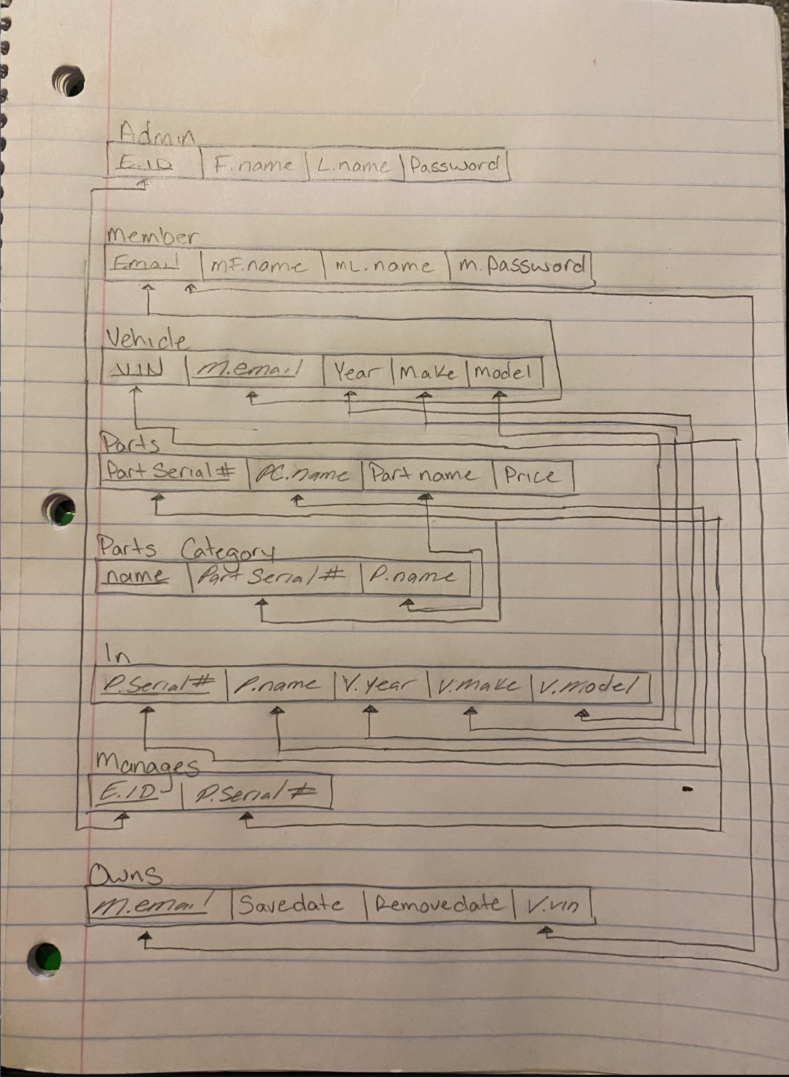

## **3.1 - Sample Queries**

### 3.1.1 Design Of Queries

1. A query that deals with 1 relation with at least 1 condition.

* **Select all members who have a Pontiac Grand Prix.**

1. A query that deals with 1 relation with at least 1 condition and 1 projection

* **Find parts that are under $100 for a Saturn e3z.**

1. A query that deals with 2 relations using a join between them

* **Find all part serial numbers of parts that fit in a Toyota Corolla.**

1. Another query that deals with 2 relations using a join between them

* **Find any members who added a vehicle after 1/1/23.**

1. A query that targets at least 3 relations using 2 joins between them

* **Select the names of parts and the admins that input those parts in the websites.**

1. Another query that targets at least 3 relations using 2 joins between them

* **Who is in charge of adding parts to category Brake**

1. A query that use aggregate functions once in the execution (relational algebra only)

* **Select the most expensive part in our part category**

1. A query that use aggregate functions twice in the execution (relational algebra only)

* **How many vehicles were saved and removed today (3/3/23)**

1. A query that uses existential negation (calculus) or set difference (algebra)

* **Who hasn’t saved a vehicle this week 3/6/23-3/10/23.**

1. A query that uses relational division

* **Find the vehicles that John Johns (**[**johnjohns@gmail.com**](mailto:johnjohns@gmail.com)**) own.**

### 3.1.2 Relational Calculus Expressions

**ALL DATA THAT WAS USED IN THIS SECTION WAS OLD MOCK DATA**



1. A query that deals with 1 relation with at least 1 condition.
2. **Select all members who have a Pontiac Grand Prix.**
3. **Find all members who own a Pontiac Grand Prix.**
4. 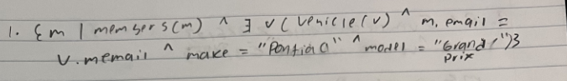
5. A query that deals with 1 relation with at least 1 condition and 1 projection
6. **Find parts that are under $100 for a Pontiac Grand Prix..**
7. **Select parts with a price less than $100 that fit Pontiac Grand Prix’s make and model.**
8. 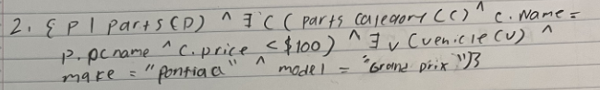
9. A query that deals with 2 relations using a join between them
10. **Find all part serial numbers of parts that fit in a** Toyota Corolla.
11. **Project the part serial numbers for any part that fits in** Toyota Corolla.
12. 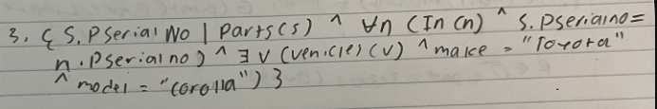

1. Another query that deals with 2 relations using a join between them
2. **Find any members who added a vehicle after 1/1/23.**
3. **Select all emails of members who own a vehicle and have a vehicle save date after 1/1/23.**
4. 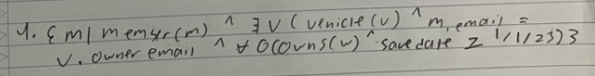
5. A query that targets at least 3 relations using 2 joins between them
6. **Select the names of parts and the admins that input those parts in the website.**
7. **Requesting a list of the specific names of the various components or elements that make up a website, as well as the names of the individuals who have administrative access and are responsible for adding or managing those parts on the site.**
8. 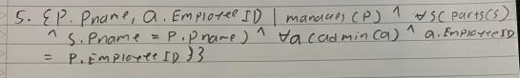

### 

### 3.1.3 Relational Algebra Expressions

**ALL DATA THAT WAS USED IN THIS SECTION WAS OLD MOCK DATA**



6. Another query that targets at least 3 relations using 2 joins between them

1. **Who is in charge of adding parts to category interior**
2. **Select all Employee IDs for Administrators who manage the parts in the parts category interior.**
3. 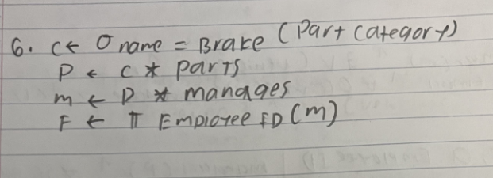

7. A query that use aggregate functions once in the execution (relational algebra only)

1. **Select the most expensive part in our part category**
2. **Project the PartCategory and maximum PartPrice for the subset of Parts where the PartCategory equals 'CategoryName**
3. 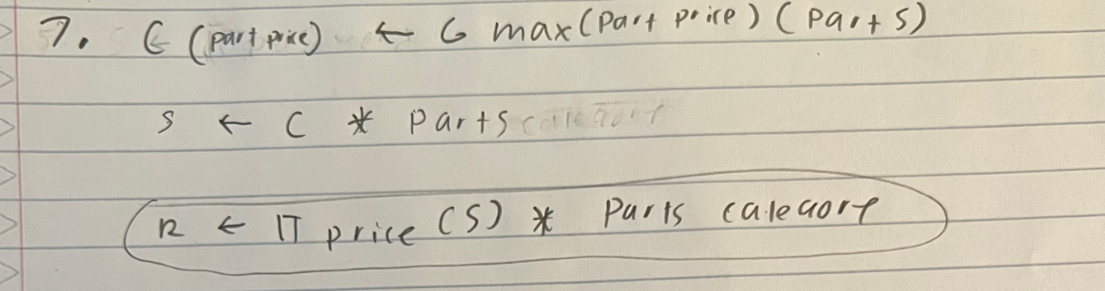

8. A query that use aggregate functions twice in the execution (relational algebra only)

1. **How many people saved vehicles today (3/3/23)**
2. **Find the count of of people that saved vehicles on the date 3/3/2023**
3. 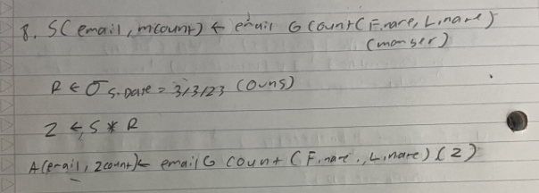

9. A query that uses existential negation (calculus) or set difference (algebra)

1. **Who hasn’t saved a vehicle this week 3/6/23-3/10/23.**
2. **Select the emails of members who own a vehicle and have not saved a vehicle between 3/6/23 and 3/10/23**
3. 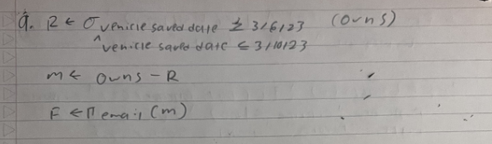

10. A query that uses relational division

1. **Find the vehicles that** [**yiacovino7@yahoo.com**](mailto:yiacovino7@yahoo.com) **own.**
2. **Retrieve all the vehicles that** [**yiacovino7@yahoo.com**](mailto:yiacovino7@yahoo.com) **own by projecting the make, model, and OwnerEmail from vehicle and divide it by the projection of email from member.**
3. 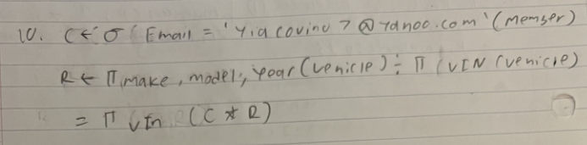

## **3.2 - Database Implementation**

### 3.2.1 Background Information

Relational databases are a type of database that provides access and stores data points that are related to each other. Relational databases are based on relational models which are used to model data in the form of tables or relations that are converted from the ER diagram.

The main purpose of RDBMS is to provide an effective well organized way to manage large amounts of data by allowing any user to modify, query and create a database. It allows users to create tables to store large amounts of data in structured tables where they are linked with each other by relations. Another purpose of RDBMS is to allow users to use SQL to retrieve data quickly and easily.

Some advantages of using client-server relational database management software are that it supports client-server architecture and has centralized data management where all clients can access and modify data simultaneously. It also allows multiple clients to access and modify data at the same time. RDBMS also offers high security such as encryption, authentication, and access control.It also offers data integrity features such as constraints, triggers, and referential integrity. RDBMS are also designed to be ACID compliant, which makes it certain that transactions are processed in a consistent and reliable manner.

Even with the advantages that RDBMS offers it also has some disadvantages over simpler storage schemes. One of these disadvantages is the cost of it. It can be expensive to maintain and acquire since they require specialized hardware and software. It can also be complex and difficult to maintain and set up since it requires expertise and knowledge to optimize, administrate, and design. RDBMS can be also slower than simpler storage schemes especially involving large amounts of data. RDBMS are designed to run on a single server which can limit their scalability.

Sources

<https://www.oracle.com/database/what-is-a-relational-database/#:~:text=A%20relational%20database%20is%20a,of%20representing%20data%20in%20tables>.

<https://www.geeksforgeeks.org/relational-model-in-dbms/>

<https://webandcrafts.com/blog/advantages-disadvantages-rdbms/#:~:text=RDBMS%20offers%20a%20high%20degree,elements%20can%20be%20accessed%20individually>.

### 3.2.2 Schema

SET foreign_key_checks=0;

DROP TABLE IF EXISTS Owns;

DROP TABLE IF EXISTS FitsIn;

DROP TABLE IF EXISTS Manages;

DROP TABLE IF EXISTS Parts;

DROP TABLE IF EXISTS PartsCategory;

DROP TABLE IF EXISTS Vehicle;

DROP TABLE IF EXISTS Member;

DROP TABLE IF EXISTS theAdmin;

CREATE TABLE theAdmin(

EmployeeID INTEGER PRIMARY KEY AUTO_INCREMENT,

Fname VARCHAR(20) NOT NULL,

Lname VARCHAR(35) NOT NULL,

Passwd VARCHAR(100) NOT NULL

);

CREATE TABLE Member(

Email VARCHAR(100) PRIMARY KEY NOT NULL,

Fname VARCHAR(20) NOT NULL,

Lname VARCHAR(35) NOT NULL,

Passwd VARCHAR(100) NOT NULL

);

CREATE TABLE Vehicle(

VIN CHAR(17) Primary Key NOT NULL,

Year INTEGER NOT NULL,

Make VARCHAR(100) NOT NULL,

Model VARCHAR(100) NOT NULL,

OwnerEmail VARCHAR(100),

FOREIGN KEY (OwnerEmail) REFERENCES Member (Email) ON DELETE CASCADE

);

CREATE TABLE PartsCategory(

CategoryName VARCHAR(100) PRIMARY KEY NOT NULL,

PartSerialNum INTEGER NOT NULL,

PName VARCHAR(100) NOT NULL,

FOREIGN KEY (PartSerialNum, PName) REFERENCES Parts (SerialNum, PartName)

);

CREATE TABLE Parts(

SerialNum INTEGER NOT NULL,

PartName VARCHAR(100) NOT NULL,

CategName VARCHAR (100),

PRIMARY KEY (SerialNum, PartName),

FOREIGN KEY (CategName) REFERENCES PartsCategory (CategoryName)

);

CREATE TABLE Manages(

EmployeeID INTEGER PRIMARY KEY NOT NULL,

PartSerialNum INTEGER,

FOREIGN KEY (EmployeeID) REFERENCES theAdmin (EmployeeID),

FOREIGN KEY (PartSerialNum) REFERENCES Parts (SerialNum)

);

CREATE TABLE FitsIn(

PartSerialNum INTEGER PRIMARY KEY NOT NULL,

PartName VARCHAR(100) NOT NULL,

VehYear INTEGER NOT NULL,

VehMake VARCHAR(100) NOT NULL,

VehModel VARCHAR(100) NOT NULL,

FOREIGN KEY (PartSerialNum, PartName) REFERENCES Parts (SerialNum, PartName)

);

CREATE TABLE Owns(

MemEmail VARCHAR(100) PRIMARY KEY NOT NULL,

VehVin VARCHAR(17) NOT NULL,

SaveDate DATE NOT NULL,

RemoveDate DATE,

FOREIGN KEY (MemEmail) REFERENCES Member (Email),

FOREIGN KEY (VehVin) REFERENCES Vehicle (VIN)

);

SET foreign_key_checks=1;

## 

### 4.1.1 - Introduction

In the early 1970’s, Dr. E. F. Codd attempted to apply the rigors of mathematics to data storage and retrieval. His work led to the definition of the DLS/Alpha language and the relational data model. IBM liked his work which led to a project to build a prototype based on his work called System/R. The team that worked on the project developed a simplified version of DSL which is called SQUARE, which was renamed to SEQUEL, then renamed to SQL

Structured query language (SQL) is a programming language that is used for processing and storing information into a relational database. One can use SQL language to retrieve, remove, store, update, and search information. The language is primarily focused on manipulating and managing data within a relational database.

Compared to other programming languages and platforms, SQL is distinct in several ways. SQL allows the user to focus on what operations they want to perform rather than how to perform them. This can make SQL queries more concise and simpler, as RDBMS takes care optomizing the execution of the query. SQL is also highly optomized for working with large datasets in a relational format. It includes tools such as sorting, aggregating, and filtering data, as well as joining and merging data from multiple tables.

Select queries are a type of SQL statement that is used to retrieve or fetch data from a database. This allows user to specify the column they want to retrieve and the conditions that must be met for the data to be selected.

A view is a virtual table that is created based on the select query. It can either have all the rows of a table or specific rows based on certain conditions. Views are useful for simplifying complex queries and hiding sensitive or irrelevant data from users.

A function in SQL is a reusable piece of code that performs a certain task. There are 6 categories of functions Single_row_functions, Aggregate_functions, Analytic_functions**,**  Model_functions, User_defined_functions, and Scalar functions. They are useful for reducing code duplications, simplifying complex calculations, and improving code readability.

A stored procedure is a precompiled block of SQL statements that can be executed with one single command. It accepts inputs in the form of parameters and performs some taks that might or might not return a value. Stored procedures are useful for improving database performance, enforcing security policies, and reducing network traffic.

A trigger is a type of stored procedure that is automatically executed where there is a modification to the database. Modifications such as updating, inserting, or deleting from a database. Triggers are useful for implementing complex business logic, enforcing data integrity constraints, and auditing changes to the database.

Sources

<https://aws.amazon.com/what-is/sql/>

<https://www.oreilly.com/library/view/mastering-oracle-sql/0596001290/ch01s02.html>

<https://www.geeksforgeeks.org/sql-select-query/>

<https://www.geeksforgeeks.org/sql-views/>

<https://www.geeksforgeeks.org/categories-of-sql-functions/>

<https://www.geeksforgeeks.org/what-is-stored-procedures-in-sql/>

<https://www.geeksforgeeks.org/sql-triggers/>

### 4.1.2 - Syntax of Programming Logic

* Creating a view
* CREATE VIEW view_name AS
* SELECT column1, column2, ...
* FROM table_name
* WHERE condition;
* Creating a Stored Procedure
* CREATE PROCEDURE procedure_name()
* BEGIN
* // statements that need to be executed
* END;
* Creating a Trigger
* CREATE TRIGGER trigger_name
* {BEFORE | AFTER} {INSERT | UPDATE | DELETE}
* ON table_name
* FOR EACH ROW
* BEGIN
* // statements that need to be executed
* END;
* A stored procedure is a set of SQL statements that are stored in a database and can be called by applications or other database objects. They atr used to group several SQL statements into a single unit which can be executed repeatedly which can be created using the CREATE PROCEDURE statemmenrt and used by using CALL. Thay can contain input and output parameters which could modify data in a database.
* A stored function is similar to stored procedures, but it returns a value instead of modifying data. They are used to compact complex calculations that can be reused across multiple applications and queries and are created by using the CREATE PROCEDURE statement and used by using a SQL expression that included the function name and any arguments that are required.

Sources:

<https://www.geeksforgeeks.org/difference-between-function-and-procedure/#>

<https://www.geeksforgeeks.org/mysql-creating-stored-function/>

<https://www.geeksforgeeks.org/what-is-stored-procedures-in-sql/>

<https://www.geeksforgeeks.org/categories-of-sql-functions/>

### 4.2 - Query Implementation

**ALL DATA THAT WAS USED IN THIS SECTION WAS OLD MOCK DATA**

* **A query that deals with 1 relation with at least 1 condition.**
* **Select all members who have a Pontiac Grand Prix.**
* SELECT * FROM Vehicle WHERE make = 'Pontiac' AND model = 'Grand Prix';

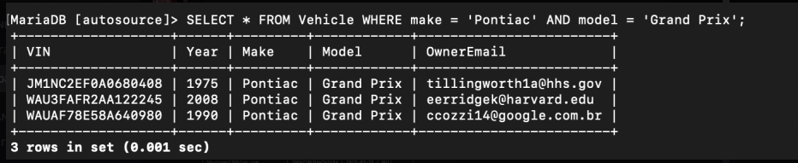

* **A query that deals with 1 relation with at least 1 condition and 1 projection**
* **Find parts that are under $100 for a Saturn e3z.**
* Select Parts.SerialNum, Parts.PartName From Parts JOIN FitsIn ON FitsIn.PartSerialNum = Parts.SerialNum WHERE Parts.Price < 100 AND FitsIn.VehMake = 'Saturn' AND FitsIn.VehModel = 'e3z';

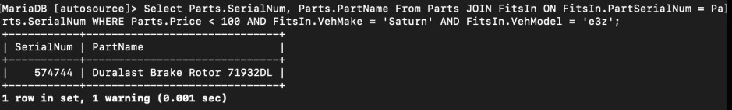

* **A query that deals with 2 relations using a join between them**
* **Find all part serial numbers of parts that fit in a Toyota Corolla.**
* Select Parts.SerialNum FROM Parts JOIN FitsIn ON Parts.SerialNum = FitsIn.PartSerialNum WHERE FitsIn.VehModel = 'Corolla' AND FitsIn.VehMake = 'Toyota';

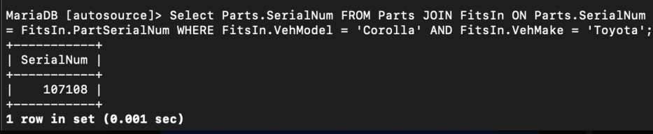

* **Another query that deals with 2 relations using a join between them**
* **Find any members who added a vehicle after 1/1/23.**
* SELECT * FROM Owns WHERE SaveDate > '2023-01-01';

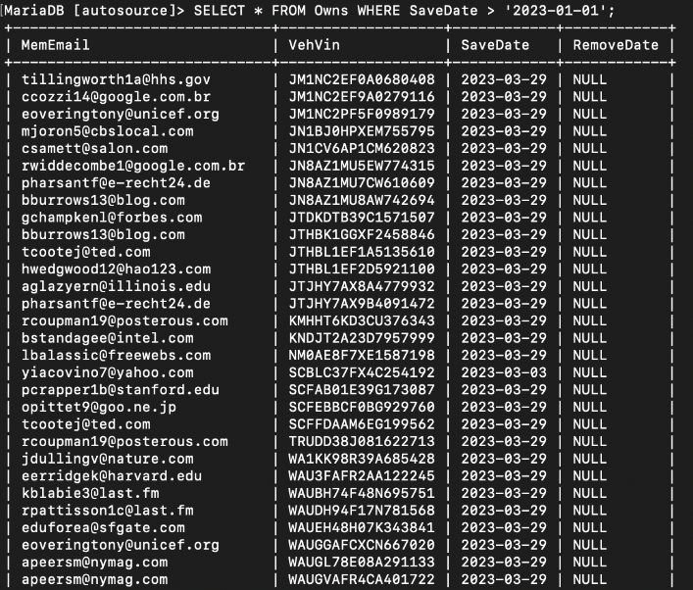

* **A query that targets at least 3 relations using 2 joins between them**
* **Select the names of parts and the admins that input those parts in the website.**
* SELECT Parts.PartName, theAdmin.Empemail FROM Parts JOIN Manages ON Parts.SerialNum = Manages.PartSerialNum JOIN theAdmin ON Manages.EmployeeID = theAdmin.EmployeeID;

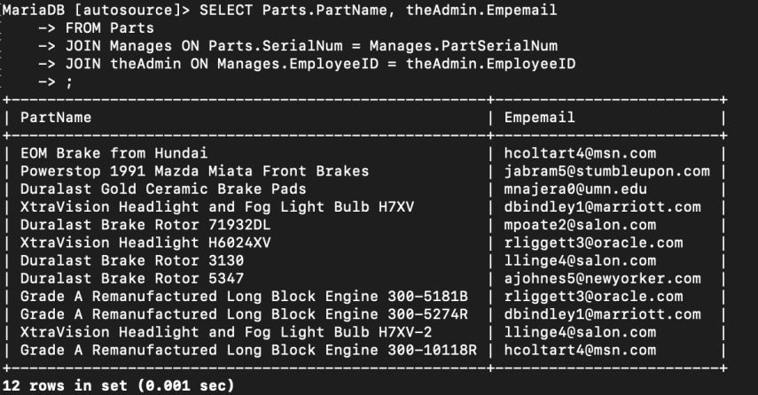

* **Another query that targets at least 3 relations using 2 joins between them**
* **Who is in charge of adding parts to category Brake**
* SELECT theAdmin.Fname, theAdmin.Lname, PartsCategory.CategoryName FROM theAdmin JOIN Manages ON theAdmin.EmployeeID = Manages.EmployeeID JOIN PartsCategory ON Manages.PartSerialNum = PartsCategory.PartSerialNum Where CategoryName = 'Brake';

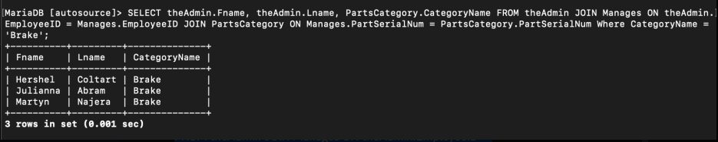

* **A query that use aggregate functions once in the execution (relational algebra only)**
* **Select the most expensive part in our part category**
* SELECT pc.CategoryName, p.PartName, MAX(p.Price) AS MostExpensivePart From Parts AS p INNER JOIN PartsCategory AS pc ON p.SerialNum = pc.PartSerialNum GROUP BY pc.CategoryName;

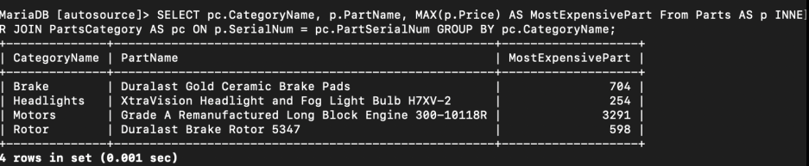

* **A query that use aggregate functions twice in the execution (relational algebra only)**
* **How many vehicles were saved and removed today (3/3/23)**
* SELECT COUNT(CASE WHEN SaveDate = '2023-03-03' THEN 1 END) AS saved_count, COUNT(CASE WHEN RemoveDate = '2023-03-03' THEN 1 END) AS removed_count FROM Owns;

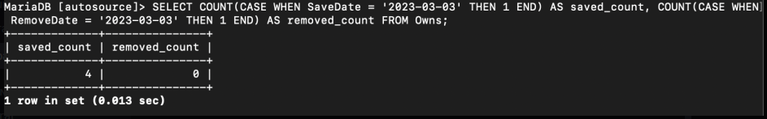

* **A query that uses existential negation (calculus) or set difference (algebra)**
* **Who hasn’t saved a vehicle this week 3/6/23-3/10/23.**
* SELECT DISTINCT MemEmail From Owns EXCEPT SELECT DISTINCT MemEmail From Owns WHERE SaveDate BETWEEN '2023-03-06' AND '2023-03-10';

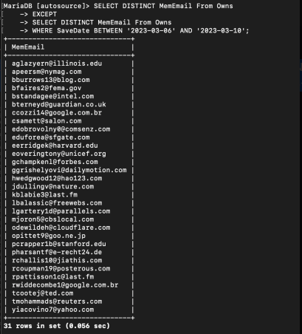

* **A query that uses relational division**
* **Find the vehicles that yiacovino7@yahoo.com own.**
* SELECT v.make, v.model FROM Vehicle v WHERE NOT EXISTS ( SELECT vi.VehVin FROM Owns vi WHERE vi.MemEmail = 'yiacovino7@yahoo.com' AND vi.VehVin NOT IN ( SELECT vi2.VehVin FROM Owns vi2 WHERE vi2.MemEmail = v.OwnerEmail ) );

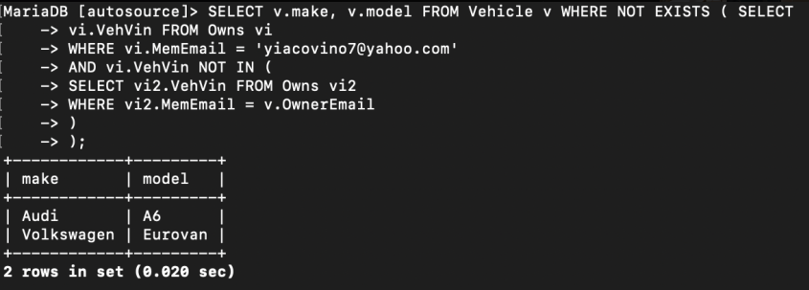

### 4.3 - Programming Implementation

#### 4.3.1 - Views

**ALL DATA THAT WAS USED IN THIS SECTION WAS OLD MOCK DATA**

* **A view for a table with certain query conditions.**
* **View for pontiac owners**
* drop view if exists PontiacOwners;

CREATE VIEW PontiacOwners AS

SELECT Make, OwnerEmail

From Vehicle

Where Make = 'Pontiac';

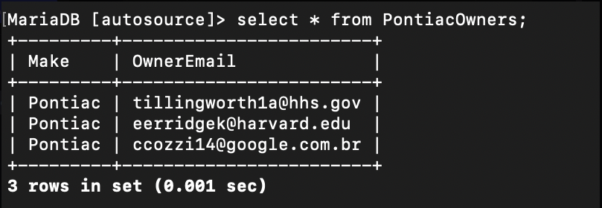

* **A view for a join between at least two tables.**
* **View that shows first name and last names of members and the make and model of what vehicle they have**
* drop view if exists VehiclesAndMembers;

CREATE VIEW VehiclesAndMembers AS

SELECT Member.Fname, Member.Lname, Vehicle.Make, Vehicle.Model

FROM Member

JOIN Vehicle

ON Member.Email = Vehicle.OwnerEmail;

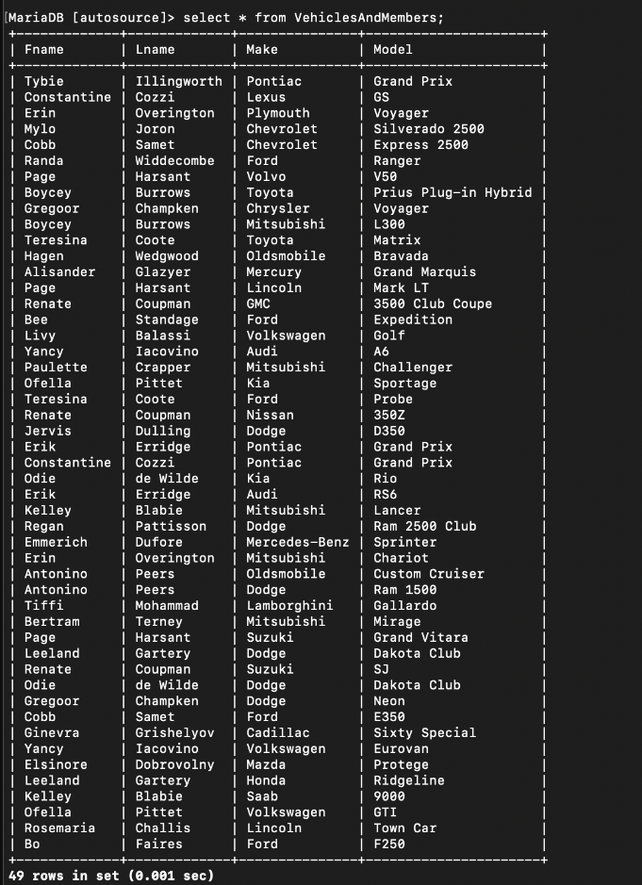

* **A view for joins between at least three tables.**
* **View that joins 3 tables show what part name and category, veh name and model, and members that have that vehicle**
* drop view if exists PartsThatFit;

CREATE VIEW PartsThatFit AS

SELECT PartsCategory.CategoryName, FitsIn.PartName, Vehicle.Make, Vehicle.Model, Vehicle.OwnerEmail

FROM PartsCategory

INNER JOIN FitsIn

ON PartsCategory.PartSerialNum = FitsIn.PartSerialNum

INNER JOIN Vehicle

ON FitsIn.VehModel = Vehicle.Model;

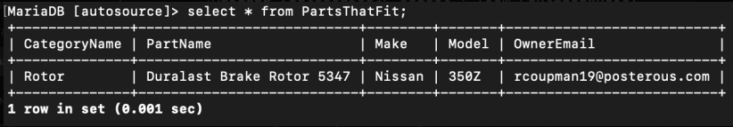

#### 4.3.2 - Stored procedures

**SOME DATA THAT WAS USED IN THIS SECTION WAS OLD MOCK DATA**

* **A stored procedure for inserting a new record into one of your tables. The field values are passed to the procedure through the input parameters.**
* A stored procedure for inputting a new user

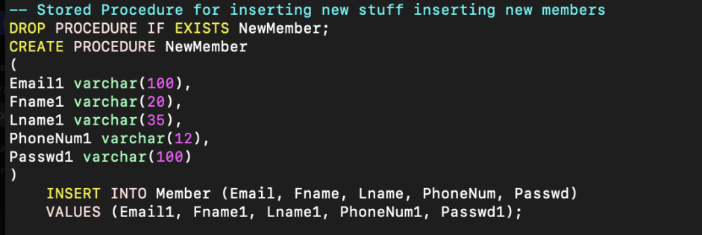

* Before

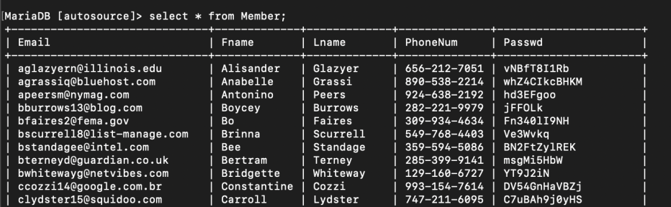

* After

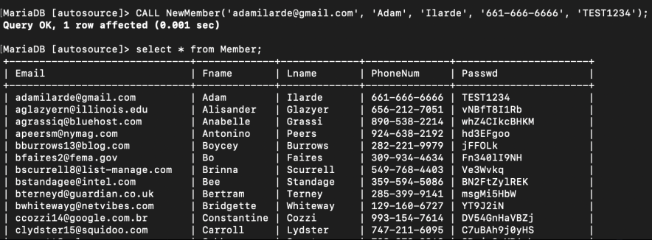

* **A stored procedure for deleting an existing record based on the primary key of your selected table.**
* Stored procedure for deleting members using email

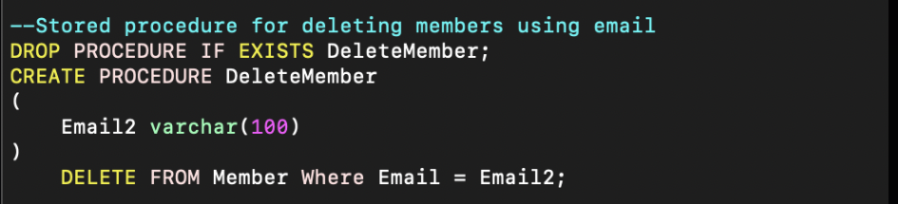

* Before

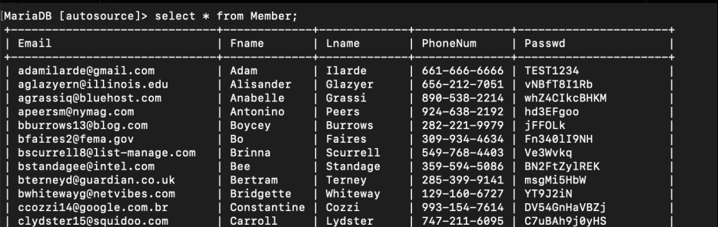

* After

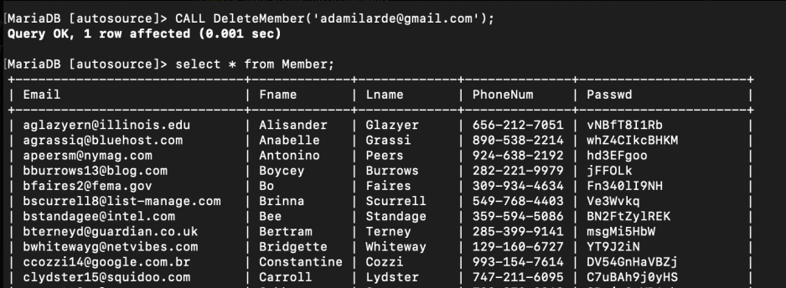

* **A stored procedure for updating an existing record based on its primary key value.**
* Stored procedure for updating a user’s password using the user’s email

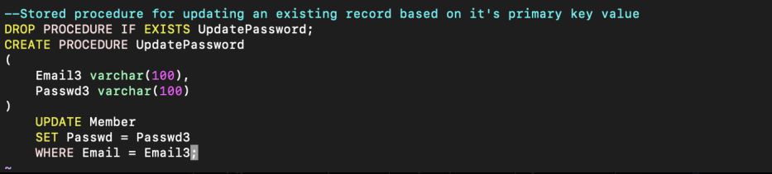

* Before

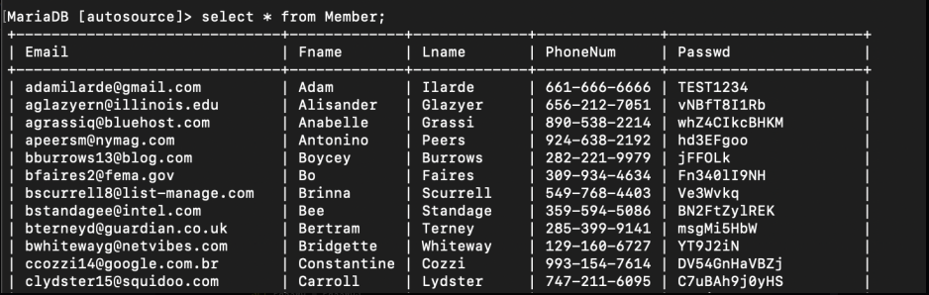

* After

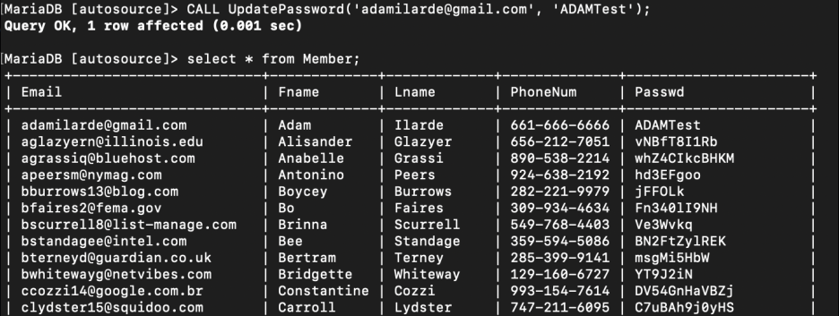

* A stored procedure which returns statistical metrics for a table over a period of time
* Return the vehicle that is saved the most

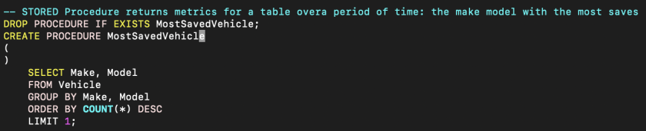

* Before

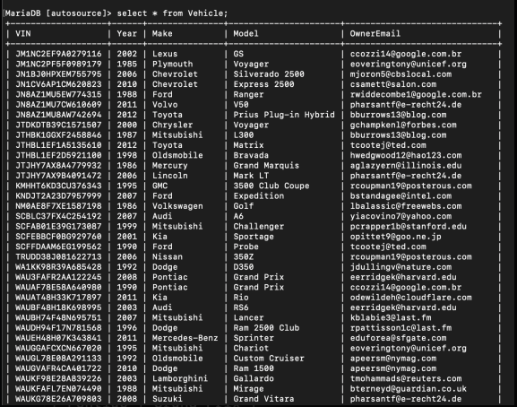

* After

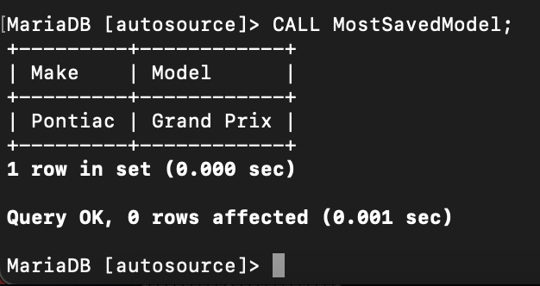

#### 4.3.3 - Triggers

* Trigger for deleting a row from a table.
* When deleting a Member from the database Owns will delete and update and remove the Member associated with a VIN from that table.
* List of Members by email who have a vehicle saved in the database.

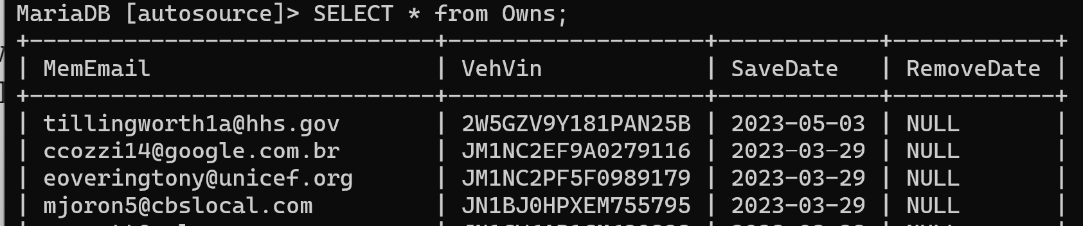

* Member associated with email that will be deleted.



* Command to delete member ‘Tybie’.



* Where a former member was in Owns table.

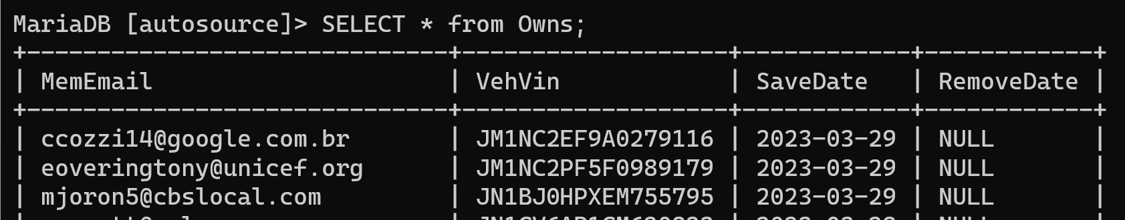

* Trigger for updating a row in a table.
* List of administrators in our database.

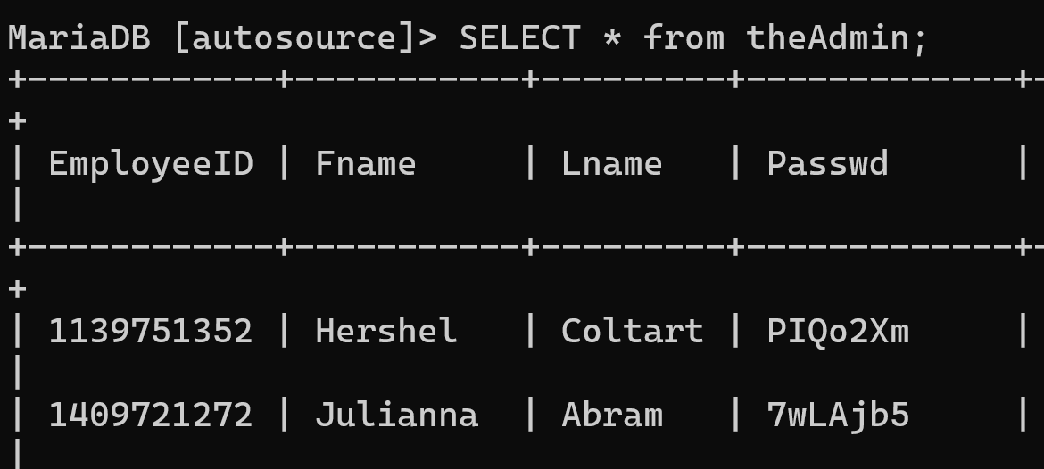

* Command to update Hershel’s Employee ID.

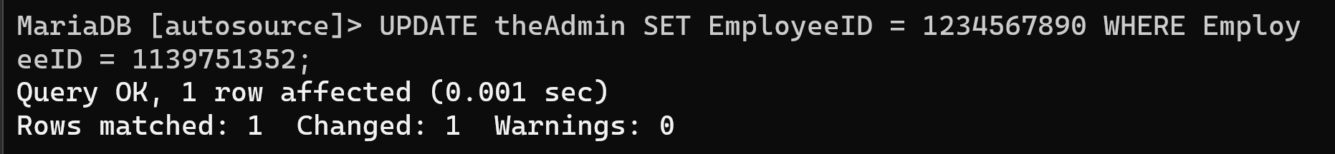

* Updated table with new employee ID.

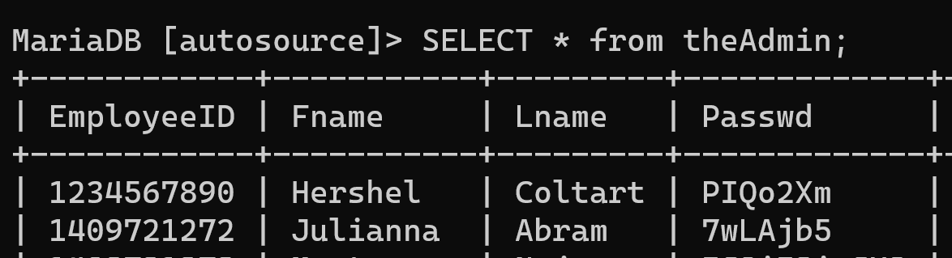

* Trigger for inserting a row into a table.
* List of parts in our Parts table.

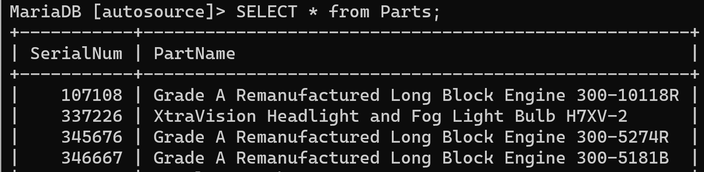

* Command to insert a new part into the table.



* Updated table of Parts with newly added item.

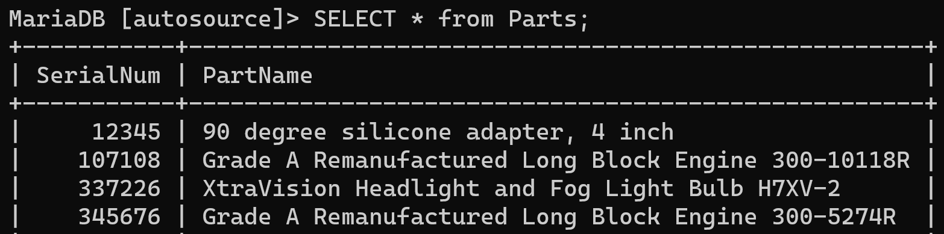

### 

### 

### 5.1 - GUI Functionalities and User Groups

* Administrator
* Manages Autosource GUI and data associated. This group is necessary to maintain and provide a clean bug free interface.
* Member
* Primary user of application and directly accesses the databases stored info by selecting vehicles and browsing compatible parts listed.
* Guest
* As a potential user to our application they can preview and view our main page but without the benefits of being a member. If interested they are capable of signing up.

#### 5.1.1 - User Capabilities

Our GUI supports three user group administrators, members, and a guest. Members and guests share a similar experience on our site but a guest does not have an account, therefore, they are unable to save a vehicle and search for parts. They are able to view our main landing page and can be redirected to a sign up page. Additionally, our members have different experiences compared to administrators' access. As an administrator along with the features that a member can do they are able to update the database with additional parts and update prices on stored parts. Another key difference is the ability to delete member accounts and vehicles.

#### 5.1.2 - Screenshots and Walkthrough

* This is the main page of the website.

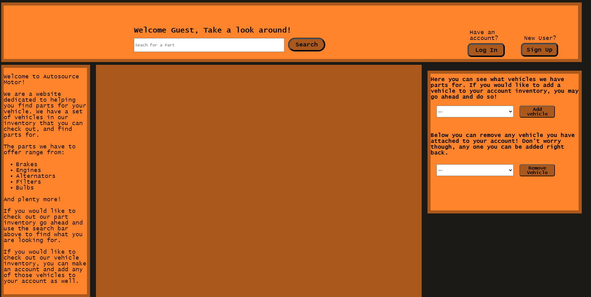

* Anybody can look around the site without signing up or logging in. They can just browse parts, for example a user can search up air filters in the search bar and it would show all the different air filters.

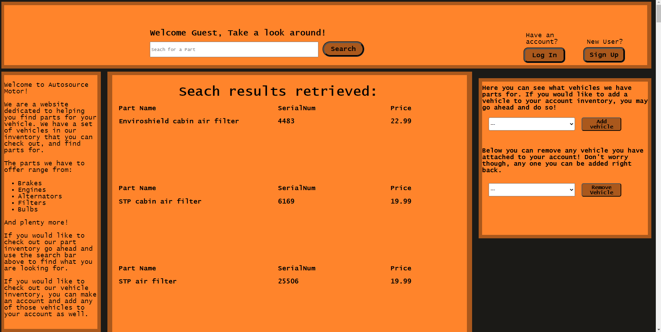

* A user can see what part fits in what vehicle by signing up to become a member or for the ones who already have an account can log in.

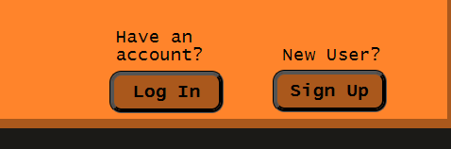

* This is the Sign up page where new users can become members and have access to the website fully.

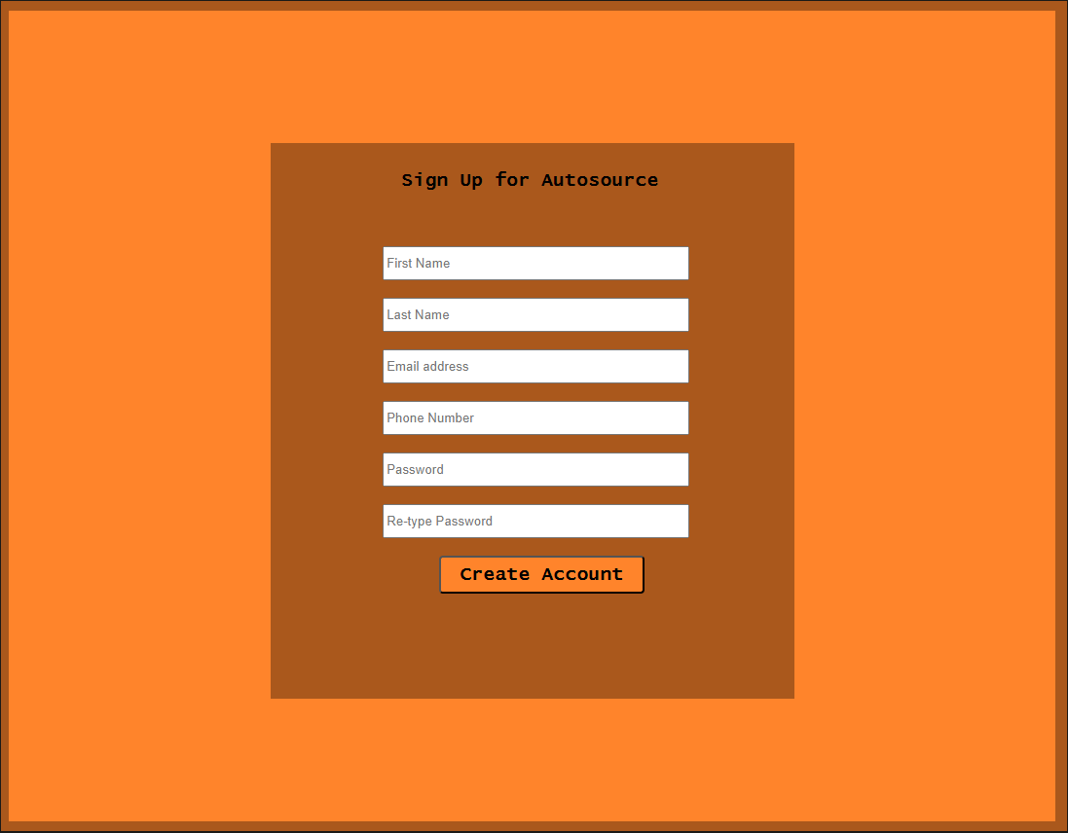

* This is the Login page where returning members can access their data.

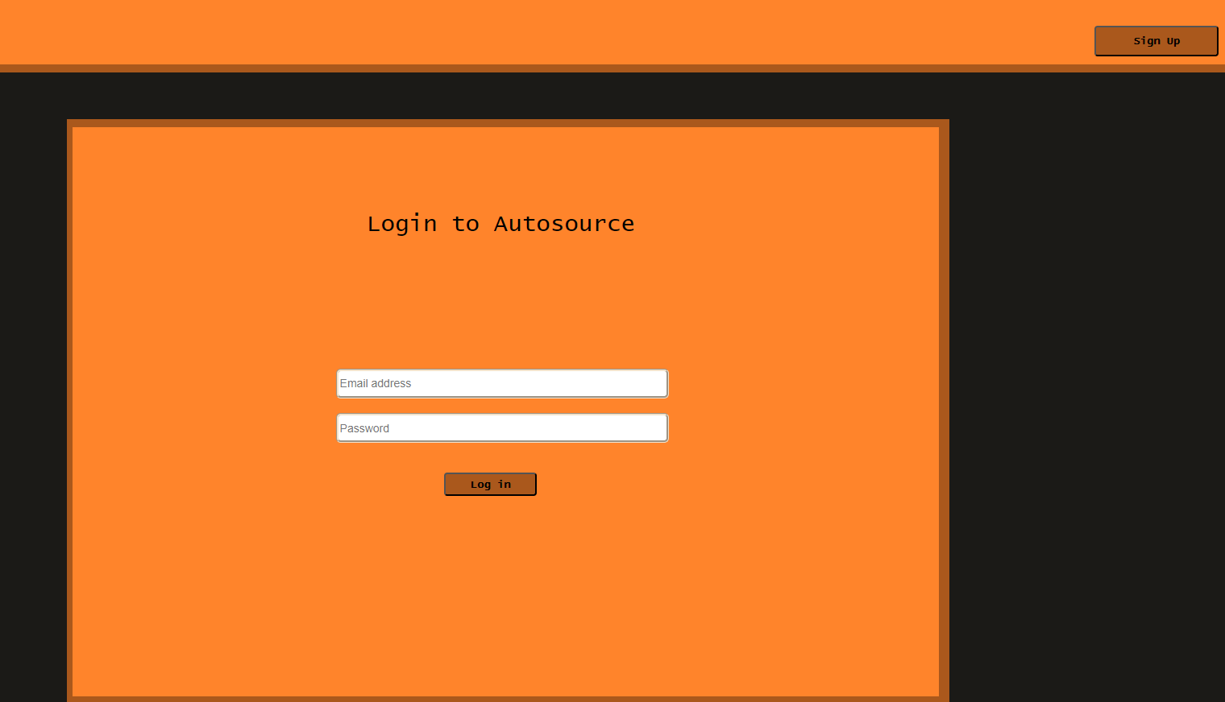

* This is the main page when a member signs in notice there are pick a vehicle and pick a part section.

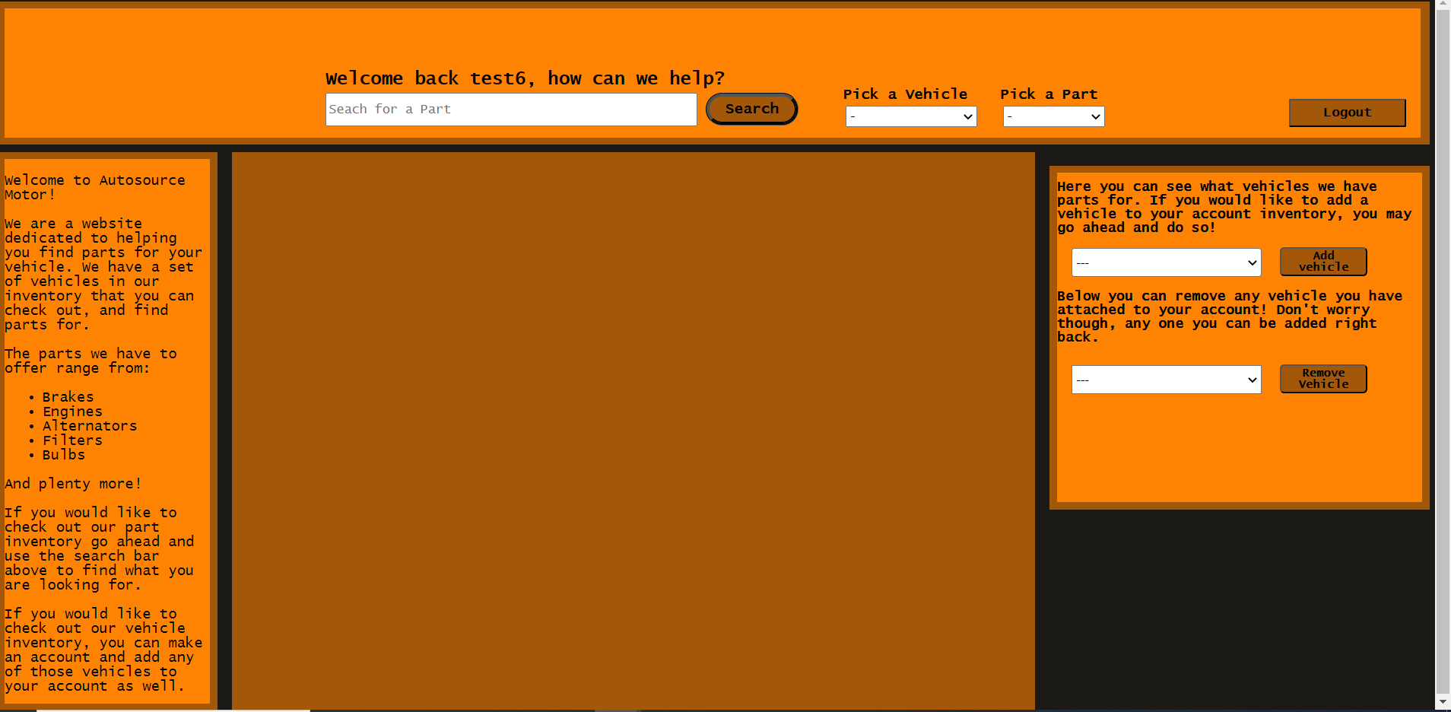

* When going on the Pick a vehicle section it would list the member’s vehicles that are saved in the database.

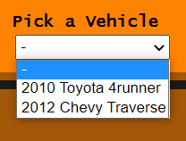

* When going on the Pick a Part section there would be a dropdown menu that lists the part categories.

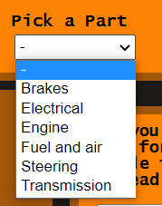

* So when searching for a part, picking a vehicle, and picking a category it would then lists the parts that are associated with that vehicle and category.

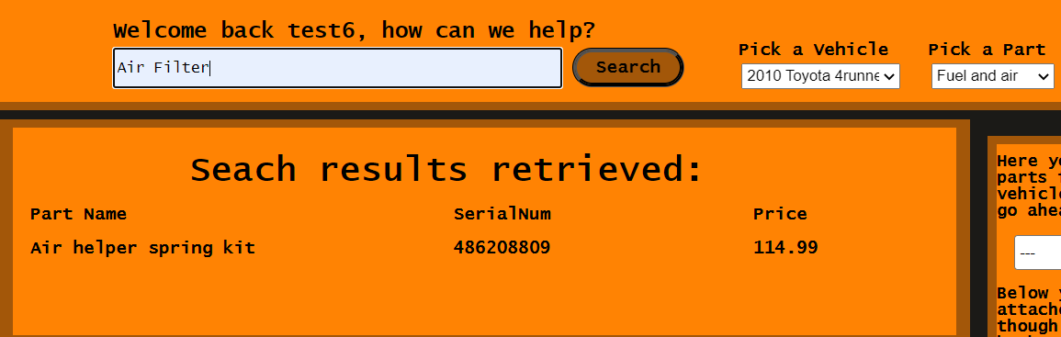

* When members sign in they have access to add and remove vehicles to their accounts here.

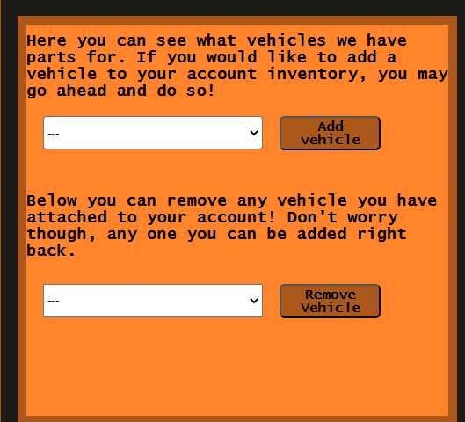

* Members can add their vehicles to the site by going to the add vehicle section. When clicking the add vehicle menu it would then list different types of vehicles a member wants to add to their account. In this example we will add a 2010 Chevy Avalanche.

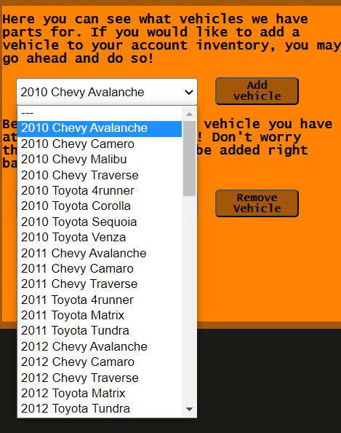

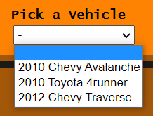

* Members can remove vehicles from their account as well by going to the remove vehicle section. It would list all the vehicles that are saved on the account. We will now remove the Avalanche.

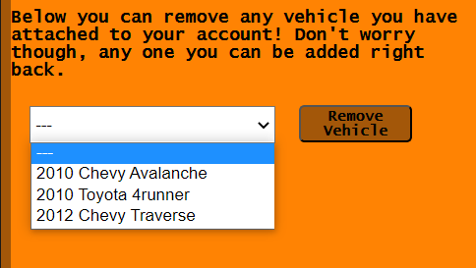

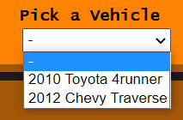

### 5.2 - GUI Programming

#### 5.2.1 - Server-side Programming

* **Views**
* **View for pontiac owners**
* This view is used to show all members that own a vehicle made by Pontiac. Its intended use is to return Pontiac owners emails. This would not be used in the GUI because this is member information that will not go public. This is intended to be used for the Administrator user group because this returns all Pontiac owners which will help with metrics.
* **View that shows first name and last names of members and the make and model of what vehicle they have**
* This view’s intended purpose is to show the first names and last names of members and what vehicle they have saved in our database. This would not be used in the GUI because this is member information that will not go public. This view is intended for the Admin user group because this would help them narrow down what member owns what vehicle.
* **View that joins 3 tables show what part name and category, veh name and model, and members that have that vehicle**
* This view’s intended purpose is to show what car make and model a member has and what ports that would fit in that vehicle. In the example using the example data it returns the owner’s email, vehicle make and model, the part name, and what category would that part be in. This would be used for the Member user group because it would show what parts would be able to fit in their vehicles.
* **Procedures**
* **A stored procedure for inputting a new user**
* This stored procedure’s intended purpose is to add a new user to a database. A new member can input their email, first and last name, phone number, and password to be saved. Their information would be saved in the database until it is removed. This would be considered the sign up page for new users who would want to sign up. This would be used for the Member user group because it is where potential members go to sign up to be a member of the website.
* **Stored procedure for deleting members using email**
* The intended purpose of this stored procedure is to remove the member’s information from the database. Whenever a member wants to remove their information from the website they can. To do this they need to provide their email which would lead to deletion of their information. This would be used by the members user group because they can remove their account and would be also used by the administrator user group because they can also delete member information.
* **Stored procedure for updating a user’s password using the user’s email**
* The purpose of this procedure is to have a user update their password. Whenever a member wants to update their password they are able to use their email which would lead them to be able to change their password. This is mainly used by the Member user group because it is their choice if they want to change their password. It can also be used by the admins because they can also change the member’s email when it is necessary.
* **Return the vehicle that is saved the most**
* The purpose of this procedure is to return the vehicles that have been saved the most in the database. For example when running the procedure with the old mock data it would return Pontiac Grand Prix. This would be used by the administrator user group because it would be used for metrics over time and would show the most common saved vehicle over time.
* **Triggers**
* **Trigger for deleting a row from a table.**
* The trigger to delete a member is used by both user groups as an administrator and as a user member. If an administrator deletes a member the trigger will update all data relating to the users email which includes the saved vehicle. If the member themselves chooses to delete their account before removing their vehicle the trigger will do it. A way this is used in our interface is on the right-side of our page you can remove your vehicle from your account. The vehicle is stored on a separate table called ‘Owns’, and when removing the vehicle from that table it updates the member table by removing the VIN associated.
* **Trigger for updating a row in a table.**
* Our trigger to update an administrator's employee ID is not used by the member group only by an adminstrator. This feature is not directly being used on our application, because there is not a situation where an employee ID would be changed only removed, unless it needed to be modified based on a promotion or possible rehire. We made this trigger to demonstrate that although unlikely we are wanting to cover all our bases.
* **Trigger for inserting a row into a table.**
* Our trigger for inserting a row into a table in the Parts database is an administrator only capability, and is not used directly on our site but rather on the back end dealing with a command terminal. To keep the application up to date administrators must be capable of updating the parts list.

#### 5.2.2 - Middle-tier Programming

* **Code to establish the database connection**
* <?php
* $dbhost = "localhost";
* $dbstring = "autosource";
* $con = mysqli_connect($dbhost, $dbstring,$dbstring,$dbstring);
* if(!$con){
* echo mysqli_connect_error();
* die();
* }
* ?>
* **Code to execute a query and store the results in an array for later use**
* $vehicle_inventory_query = "SELECT Year, Make, Model FROM Vehicle GROUP BY Year, Make, Model";
* $vehicle_result = mysqli_query($con, $vehicle_inventory_query);
* $vehicle_table = array();
* while ($row = mysqli_fetch_array($vehicle_result)) //Makes an array of every vehicle bases on Year, Make and Model
* {
* $vehicle_table[]= array(
* 'Year' => $row['Year'],
* 'Make' => $row['Make'],
* 'Model' => $row['Model']
* );
* }
* **Code to check for user session for the users data from our Members table if they are signed in**
* <?php
* function check_login($con)
* {
* if(isset($_SESSION['user_id']))
* {
* $id = $_SESSION['user_id'];
* $query = "SELECT * FROM Member WHERE Email = '$id'";
* $result = mysqli_query($con, $query);
* if($result && mysqli_num_rows($result) > 0)
* {
* $user_data = mysqli_fetch_assoc($result);
* return $user_data;
* }
* }
* return [];
* }

#### 5.2.3 - Client-side Programming

* **Viewing from our search list the results of parts we receive:**
* <div id="Main_Container">
* <div id="Inside_Main_Container">
* <?php if($Search_Clicked == False){
* }elseif($Search_Clicked == True){
* echo"<p id='SearchedResultsText'> Seach results retrieved: </p>";
* if(empty($ChosenCarParts)){
* echo"<p id='ErrorNoParts'>Uh Oh! Seems like we have no parts in stock for this vehicle!</p>";
* }else{
* foreach($ChosenCarParts as $result){
* $PriceQuery = "SELECT Price FROM Parts WHERE SerialNum = $result[PartSerialNum]";
* $QueryResult = mysqli_query($con, $PriceQuery);
* $Price = mysqli_fetch_assoc($QueryResult); ?>
* <div id="SearchedPartName"> Part Name <br> <?php echo"$result[PartName]" ?> </div>
* <div id="SearchedSerialNumber"> SerialNum <br> <?php echo"$result[PartSerialNum]" ?></div>
* <div id="SearchedPrice"> Price <br> <?php echo"$Price[Price]" ?></div>
* <?php } ?>
* <?php } ?>
* <?php } ?>
* </div>
* </div>
* **Difference in a user and a guest accessing our inventory dropdown and when they try to add the car to their account:**
* <form method="POST" action="index.php">
* <select id="Vehicle_Dropdown" name="vehicle_inventory">
* <option selected="selected">---</option>
* <?php foreach($vehicle_table as $vehicle){ ?>
* <option value="<?php echo $vehicle['Year'] . '|' . $vehicle['Make'] . '|' . $vehicle['Model']; ?>">
* <?php echo $vehicle['Year'] . ' ' . $vehicle['Make'] . ' ' . $vehicle['Model']; ?>
* </option>
* <?php } ?>
* </select>
* <?php if($session_mode == "member"){ ?>
* <button type="submit" id="Add_Vehicle" name="add_vehicle">Add vehicle</button>
* <?php } ?>
* </form>
* <?php if($session_mode == "guest"){ ?>
* <a href="login.php">
* <button id="Add_Vehicle_Guest">Add vehicle</button>
* </a>
* <?php } ?>